

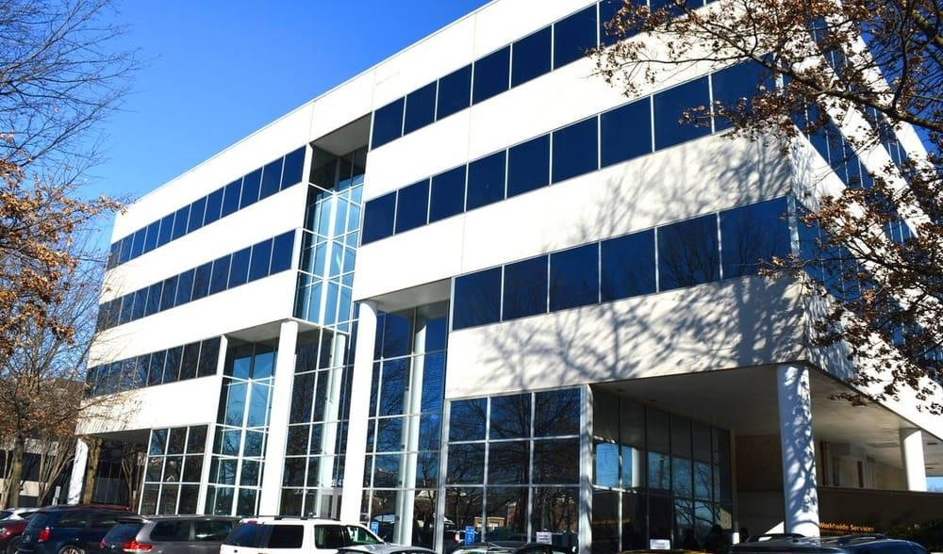
Welcome to Sleep and TMJ Therapy! We would like to help you make the most of your visit. Included is a list of local attractions, eateries, lodging, and travel options for your convenience. Please feel free to contact us with any questions or concerns. We look forward to meeting and working with you!

Office Information:
Address: 2841 Hartland Road Suite 301 Falls Church, VA 22043
Website: www.sleepandtmjtherapy.com
Office number: 1(703) 821-1103
Email: Office@sleepandTMJtherapy.com Office Hours: Monday-Friday 7:00am-4:00pm; Alternating Saturdays for TMJ Massages 8:00am – 12:00pm

*Anything underlined can be clicked on and it will redirect you to the corresponding weblink. Enjoy!

TRANSPORTATION


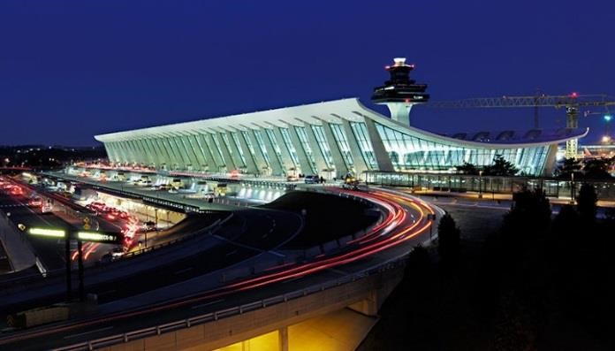
Local Airports:

Dulles International Airport
Airport code: IAD
1 Saarinen Cir, Dulles, VA 20166 Located 20.1 miles from our office.

Ronald Reagan National Airport
Airport Code: DCA
1 Aviation Circle, Washington, DC 20001
Located 19.3 miles from our office. (Dulles International Airport)

Baltimore Washington International Airport
Airport Code: BWI
7050 Friendship Rd, Baltimore, MD 21240
Located 50.4 miles from our office.

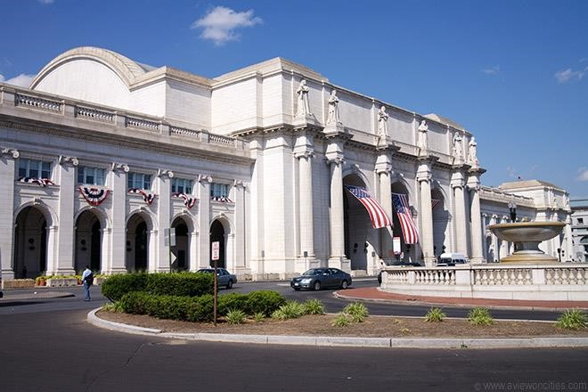
Train Stations:
www.amtrak.com

Union Station (Train Station)
50 Massachusetts Ave NE Washington, DC 20002
Located 11.7 miles from our office.

Alexandria Union Station (Train Station)
110 Callahan Drive, Alexandria, Virginia 22314
Located 14.5 miles from our office.
(Union Station Train Station)
Local Transportation Services:

Dunn Loring Metro
2700 Gallows Rd Vienna, VA 22180
Located .8 miles from our office.

Yellow Cab Taxi
1(703) 534-1111

TRANSPORTATION CONT…

Vienna Taxi and Airport Service

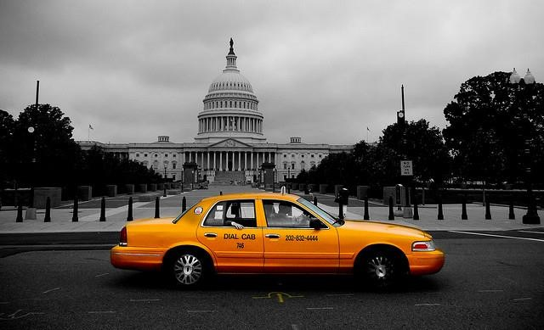
1(703) 822-4750

Washington Dulles Taxi
1(703) 288-3331

Enterprise Rent-a-car
1592 Spring Hill Rd Vienna, VA 22182
1(703) 356-6370

Reston Express Taxi
1(703) 402-1137 (Yellow Cab)

Instead of a taxi, use UBER

Request a ride using the app or website and get picked up within minutes.
On-demand service means no reservations, faster service, and MUCH CHEAPER!


How to use Uber:
- Download the App on your smart phone called Uber or visit www.uber.com
- Create an account and add your debit card to your account.
- When you are ready to leave, type in your location and request an Uber driver.
- Keep an eye on the map to see where your driver is. (Your driver will also call you when he/she arrives.)
- Either enter in your destination in the app or tell the driver.
- Once you have reached your destination, the charge will be applied to your card.
- (No tip, cash, or credit cards will be needed.)


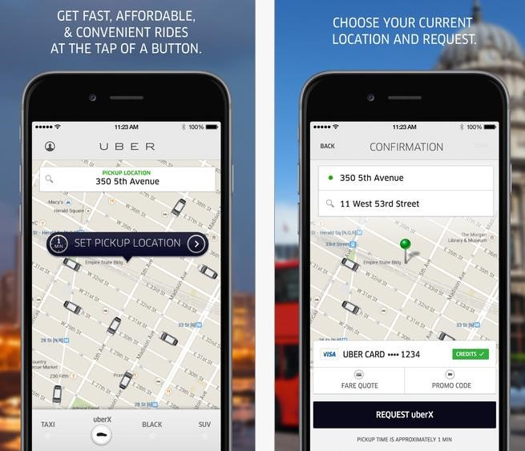
*Before your first ride, use the Promo code: Megs264 to get $15 towards your first ride!*

HOTELS

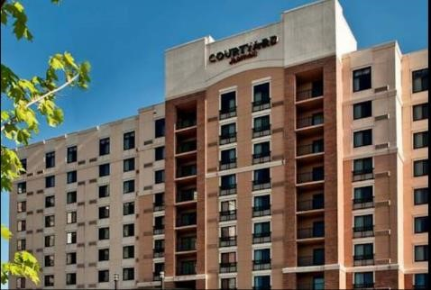
Courtyard Dunn Loring Fairfax
2722 Gallows Rd, Vienna, VA 22180
1(703) 573-9555

Archer Hotel Falls Church/Merrifield
8296 Glass Alley Fairfax, Virginia, USA, 22031
1(571) 327-2277

Homewood Suites by Hilton
8130 Porter Road, Falls Church, Virginia, 22042 1(703) 560-6644
(Courtyard Dunn Loring Fairfax)
Residence Inn Fairfax Merrifield
8125 Gatehouse Rd, Falls Church, VA 22042
1(703) 573-5200

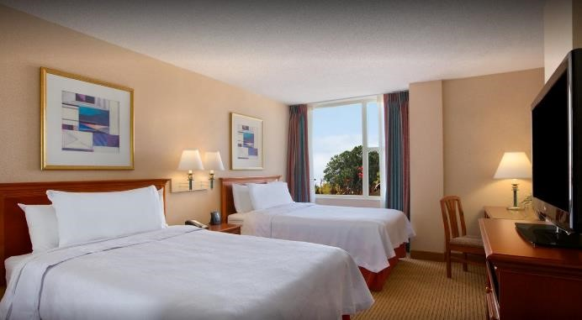
Extended Stay America
8281 Willow Oaks Corporate Dr, Fairfax, VA 22031
1(703) 204-0088

Budget Inn Falls Church
7155 Lee Highway Falls Church, VA 22046
1(703) 533-8600

Best Western
6633 Arlington Boulevard Falls Church, Virginia 22042 (Homewood Suites by Hilton)
1(703)532-9000

HOTELS CONT…

Hilton Garden Inn

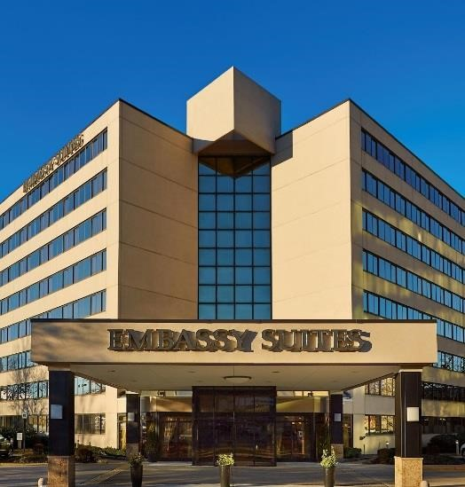
706 West Broad Street, Falls Church, Virginia, 22046
1(703) 237-8700

TownePlace Suites
205 Hillwood Ave, Falls Church, VA 22046
1(703)237-6172

Embassy Suites
8517 Leesburg Pike, Vienna, VA 22182
1(703) 883-0707

Comfort Inn
6111 Arlington Blvd, Falls Church, VA 22044
1(703) 534-9100 (Embassy Suites)

* Hotels listed are no further than 6 miles from our office.

ENTERTAINMENT


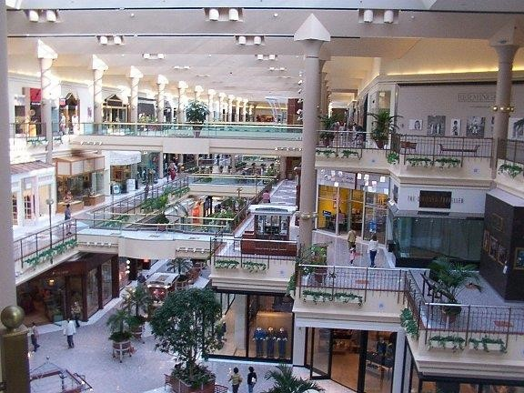
Tyson's Corner Shopping Center
1961 Chain Bridge Rd Ste 105, Mc Lean, VA 22102

Reston Zoo
1228 Hunter Mill Rd Vienna, VA 22182
1(703) 757-6222

Washington National Zoo
Connecticut Ave NW, Washington, DC 20008

Meadowlark Botanical Gardens
9750 Meadowlark Gardens Ct Vienna, VA 22182
1(703) 255-3631 (Tysons Corner Shopping Center)

ENTERTAINMENT CONT….

Uncork'd (Painting and Beverages)


1834 Columbia Rd. 3rd Floor Washington, DC 20009

1(888) 317-1047

Woody's Golf Range
11801 Leesburg Pike Herndon, VA 20170
1(703) 430-8337

AMC Tyson's Corner (Movie Theater)
7850 Tysons Corner Center McLean, VA 22102
1(703) 734-6212

Tyson's Galleria (Shopping and Dining)
(Washington National Zoo) 2001 International Drive McLean, VA 22102
1(703) 827-7730


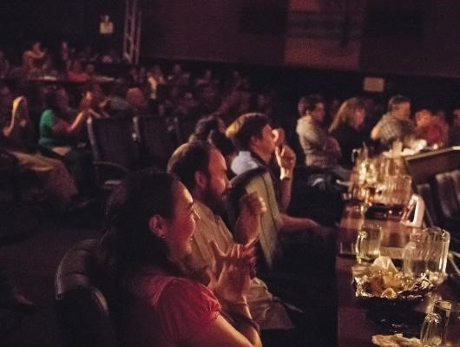
Ultra-Zone Laser Tag
3447 Carlin Springs Rd Falls Church, VA 22041
1(703) 578-6000

Chuck E. Cheese
9404 Main St, Fairfax, VA 22031
1(703) 978-5755

Arlington Draft House
2903 Columbia Pike Arlington, VA 22204
1(703) 486-2345

Bowl America Website (Arlington Draft House)
9699 Fairfax Blvd, Fairfax, VA 22031
1(703) 273-7700

ENTERTAINMENT CONT…
National History Museum
10th St. & Constitution Ave., NW, Washington, D.C., 20560


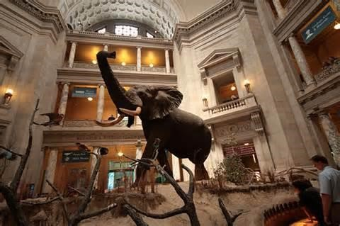
Mosaic District (Shopping and Dining)

)

2905 District Ave, Fairfax, VA 22031

National Aquarium
Baltimore Inner Harbor, Baltimore, MD 21202

Top Golf
6625 S Van Dorn St Alexandria, VA 22315
1(703) 924-2600

Clemyjontri Park
6317 Georgetown Pike Mclean, VA 22101
1(703) 388-2807 (National History Museum )

iFLY Loundoun (Indoor Sky Diving)

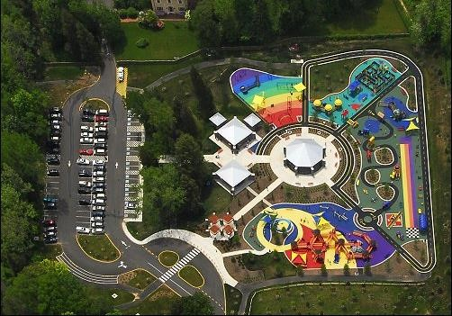
20315 Commonwealth Center Drive Ashburn, VA 20315
1(571) 446-4359

National Air and Space Museum
Independence Ave. at 6th St SW Washington, DC 20560
1(202) 633-2214

National Portrait Gallery
8th and F St. NW Washington, DC 20560

National Museum of African American History
15th and Constitution Ave. NW Washington, DC 20560
(Clemyjontri Park)
National Museum of the American Indian
4th St. and Independence Ave. SW Washington, DC 20560

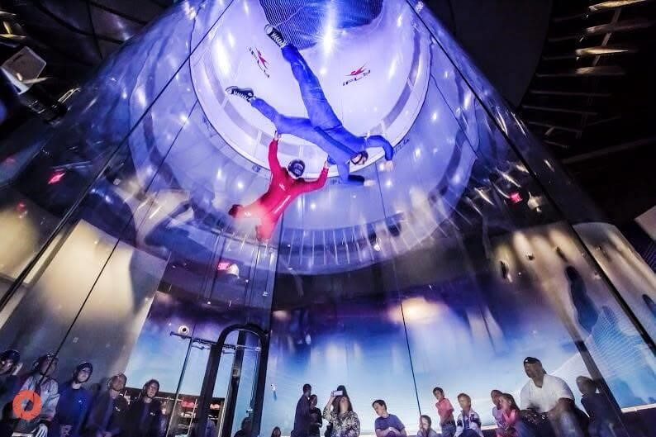

Renwick Gallery
1661 Pennsylvania Ave. NW Washington, DC 20560

Hirshhorn Museum and Sculpture Garden
Independence Ave. at 7th St. SW
Washington, DC 20560

George Washington's Mount Vernon
3200 Mount Vernon Memorial Highway,
Mount Vernon, VA 22121

(iFLY Indoor Sky Diving)

OTHER INFORMATION

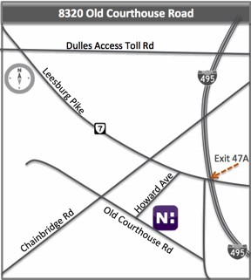
Novant Health Imaging

8320 Old Courthouse Rd. Suite 130, Vienna VA 22182
Phone: 1(703)281-0213
Fax: (703)356-4602
Located 3.3 miles from our office.

Directions from I-495: Take exit 47-A for Tyson’s Corner
Route 7 West. At second light, make a left on Gallows
Road. At second light, make a right on Old Courthouse Road. Turn Right into the building parking lot, 8320 Old Courthouse Road, Tycon One Building, Suite 130.

Directions from I-66/Curtis Memorial Pkwy West: Take exit 66B, take ramp to Leesburg Pike, turn left onto Gallows Road, turn Right into parking lot, 8320 Old Courthouse Road, Tycon One Building, Suite 130.

